**Evidence for Analysis and Design Unit.**

Rachael Ellen E20

**A.D.1 Use case Diagram**

Evidence for unit

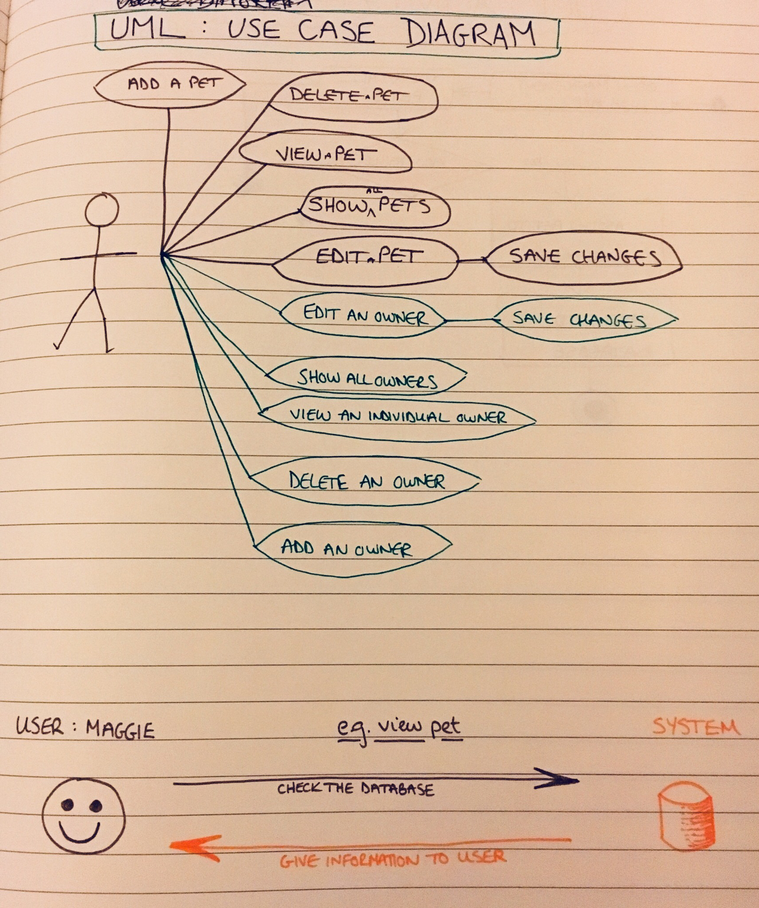

**A.D.2 Class diagram**

Evidence for unit

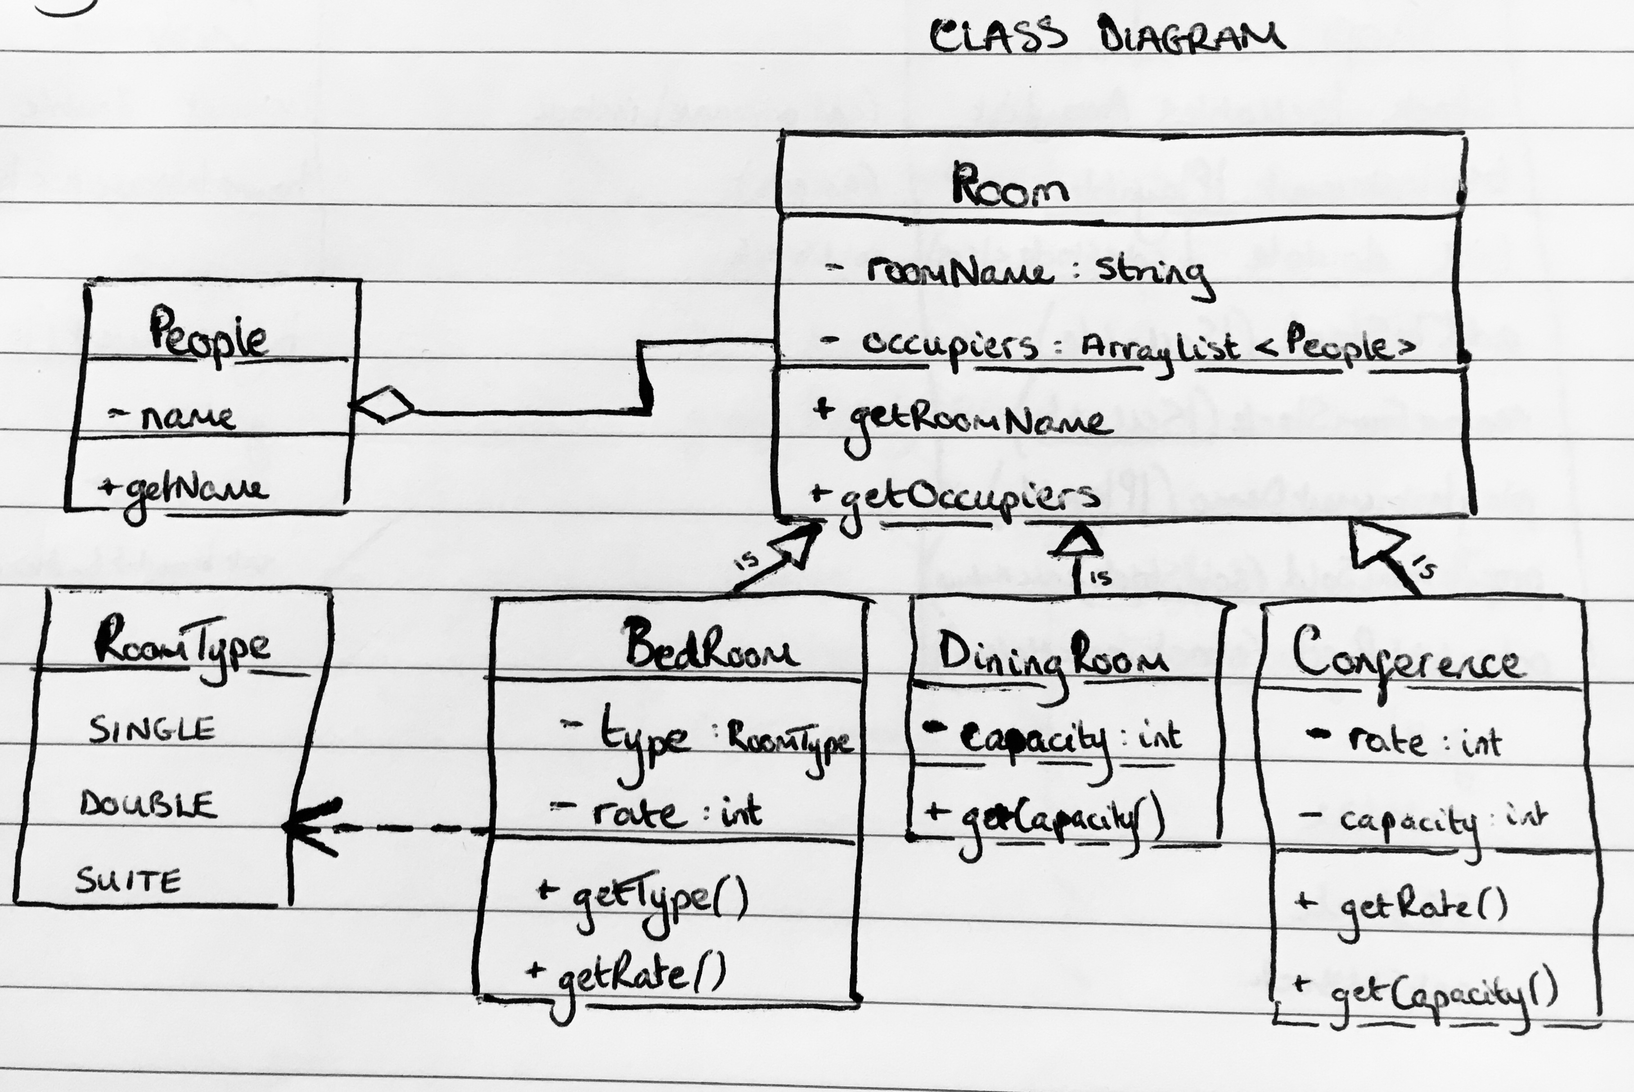

**A.D.3 Object diagram**

Evidence for unit

NOT SURE WHAT THIS IS MEANT TO BE…!

**A.D.4 Activity diagram**

Evidence for unit

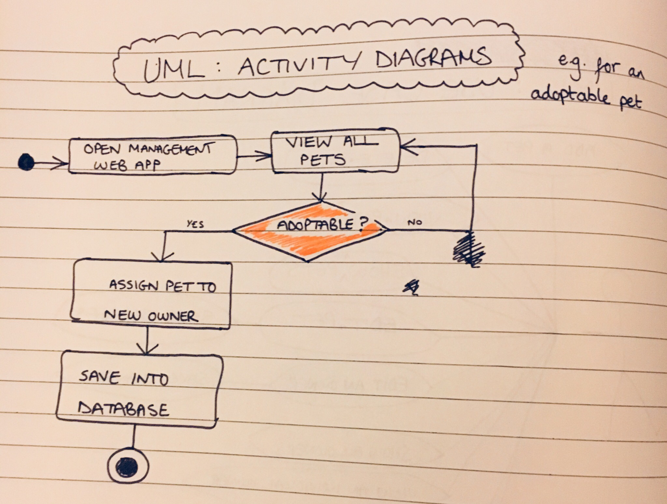

**A.D.5 Inheritance diagram**

Evidence for unit

Bedroom, DiningRoom and Conference inherit from the superclass Room

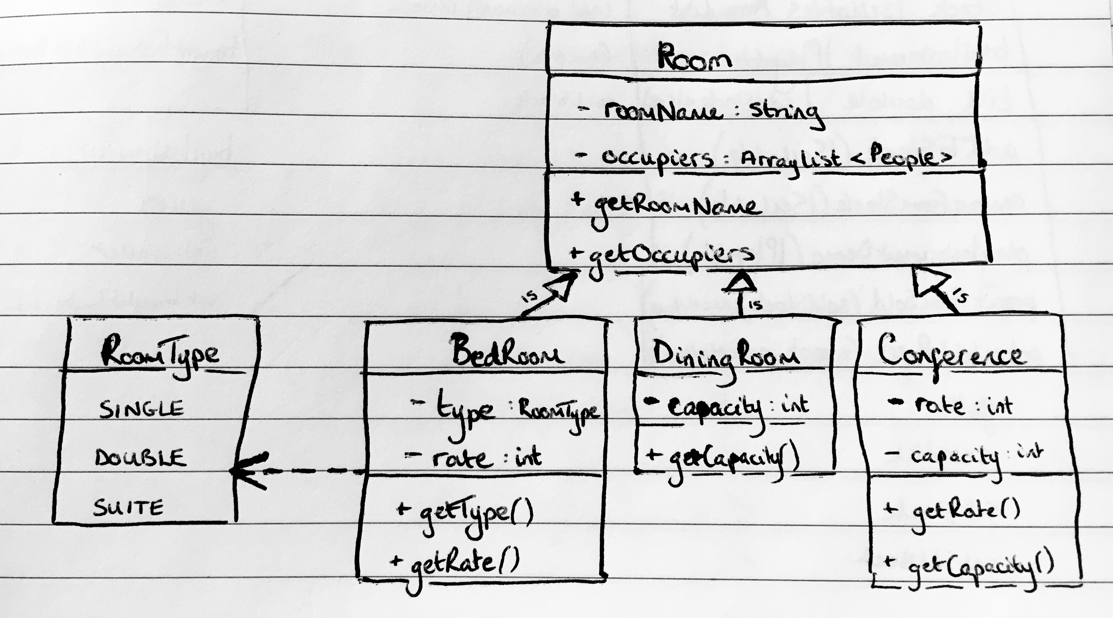

**A.D.6 Implementations Constraints**

|  |  |  |
| --- | --- | --- |
| **TOPIC** | **POSSIBLE EFFECT OF CONSTRAINT ON PRODUCT** | **SOLUTION** |
| **Hardware and software platforms** | System crashes if not enough memory | Make code more light weight, increase system memory if possible. |
| **Performance requirements** | Data unavailable on any other device than the localhost | Make data available away from localhost (store on remote server?) |
| **Persistent storage and transactions** | If database unavailable, data would not store/load | Make database available by storing on remote server? |
| **Usability** | If the interface is not clear, data cannot be entered or returned: user frustration. | Allow for smooth user interface: explain how the web app is designed to be used. |
| **Budgets** | No budget or means to host a website or remote server | Show only friends and family the app running on own laptop for now. |
| **Time limitations** | Work has to be done in a week: website design may not be completed in time. | Increase the project time, learn how to use CSS, complete website look later. |